**🧾 LLMscope Investor Prospectus – Rev A (Portrait Draft)**

**Private & Proprietary — Do Not Distribute Without Written Consent**  
Prepared by Brandan Baker | Founder & Developer | BLB3D Labs (Sole Proprietorship – LLC in Formation)  
Huntington, Indiana USA | bbaker@blb3dprinting.com  
**Disclaimer:** This document is for internal and investor-education purposes only and not an offer to sell securities.

**One️⃣ Executive Summary**

LLMscope is a **self-hosted AI performance-monitoring platform** that applies *Statistical Process Control (SPC)* and *Nelson Rules 1-8* to detect instability and reasoning strain in large-language-model (LLM) systems.  
Developed by **BLB3D Labs** in Huntington, IN, the platform delivers real-time visibility into latency, reliability, and cost across OpenAI, Anthropic future version and local Ollama models starting with v1.0.0.

**Cognitive Load Latency Discovery** — During internal research, the founder identified a consistent correlation between model reasoning complexity and response-time deviation, forming a new analytic dimension: **Cognitive Load Analysis**.  
This insight forms the proprietary basis of LLMscope’s anomaly-detection engine.

**Funding Ask:** US $500 000 Seed Round | Pre-Money Valuation ≈ US $4 000 000 | ≈ 11 % Equity.

**Two - Market Opportunity (Verified Sources)**

| **Market Segment** | **2024 Value (USD B)** | **2033-34 Projection (USD B)** | **CAGR %** | **Source** |
| --- | --- | --- | --- | --- |
| Global AI Market | 279.2 | 3 497 | 31.5 | Grand View Research 2025 |
| AI SaaS Market | 115.2 | 2 973 | 38.4 | Growth Market Reports 2025 |
| AI Model Monitoring | 1.95 | 24.5 | 33.1 | Growth Market Reports 2025 |
| AI Observability | 1.4 | 10.7 | 22.5 | Market.us 2025 |

**Key Insight:** AI model monitoring is a validated, double-digit-growth niche inside a multi-trillion-dollar AI ecosystem.

**Comparable Products & Pricing**

| **Competitor** | **Entry Plan** | **Key Differentiator Gap** |
| --- | --- | --- |
| **Langfuse Cloud** | $59/mo. | Prompt tracing only (no SPC) |
| **Opik (Pro)** | $39/mo. | No statistical detection |
| **Datadog LLM Obs.** | ≈ $8 per 10 000 requests | Cloud-only / no self-host |
| **LLMscope** | Free → $149 → $999/mo. | SPC + Cognitive Load Engine (Self-host first) |

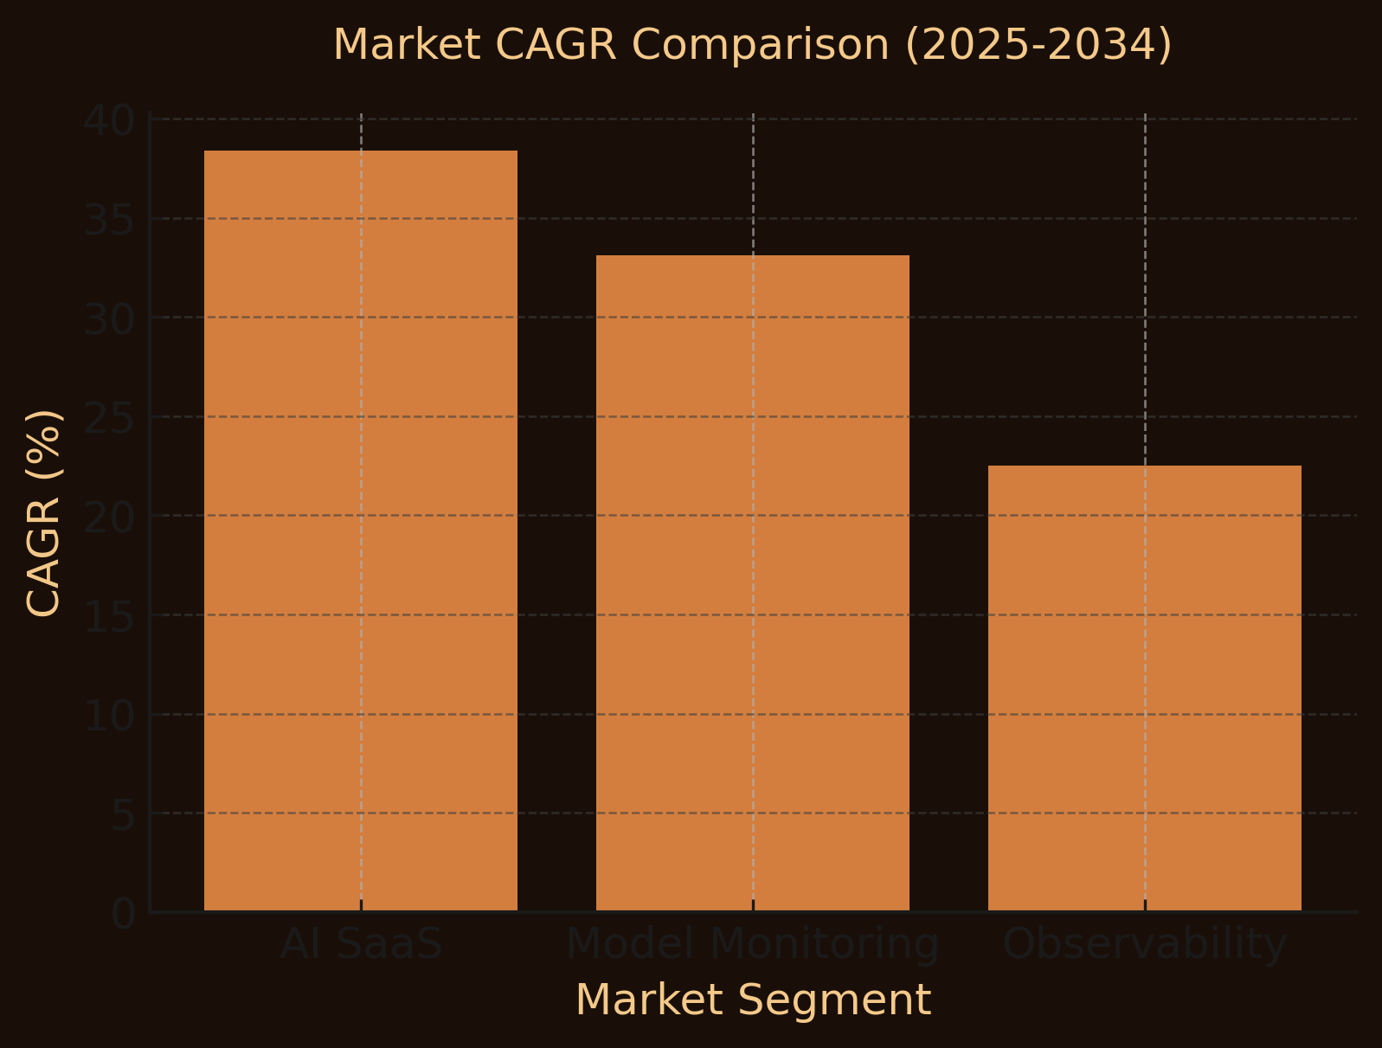

**📈 Chart 1 — *Market Growth Comparison***

**Type:** Grouped bar chart  
**X-axis:** Market Segments (AI SaaS, Model Monitoring, Observability)  
**Y-axis:** CAGR %  
**Values:** AI SaaS 38.4 | Model Monitoring 33.1 | Observability 22.5  
**Colors:** Bronze (#D37E3E) bars on Black (#1A0F08) background

**Three - Product & Technology Overview**

**Architecture**

* **Backend:** FastAPI (Python 3.11) + SQLite for telemetry and SPC math.
* **Frontend:** React 18 + Plotly + Tailwind CSS served via Nginx.
* **Monitor:** Async Python service posting latency and token data every 30 s.
* **Deployment:** Docker Compose; < 10 min setup; fully self-contained.

**Core Differentiators**

1. SPC-based AI analytics engine (mean (μ), Standard Deviation (σ), Upper Control Limit (UCL) Lower Control limit (LCL), Nelson Rules).
2. Cognitive-load detection, measuring reasoning strain.
3. Self-hosted privacy — no data leaves customer infrastructure.
4. Multi-provider compatibility (OpenAI, Anthropic, Ollama, Google, AWS).
5. Engineering-grade visual dashboard (Cp/Cpk indices, alerts).

**Four - Business Model & Pricing**

| **Tier** | **Monthly Price** | **Users** | **Retention Days** | **Key Features** |
| --- | --- | --- | --- | --- |
| Free | $0 | 1 | 7 | Community edition (self-host) |
| Starter | $49 | 3 | 30 | Basic SPC metrics + email support |
| Pro | $149 | 10 | 90 | Full SPC + Nelson Rules 1-8 + Slack support |
| Enterprise | $499-999 | Unlimited | Unlimited | SSO/SAML + custom integrations + SLA |

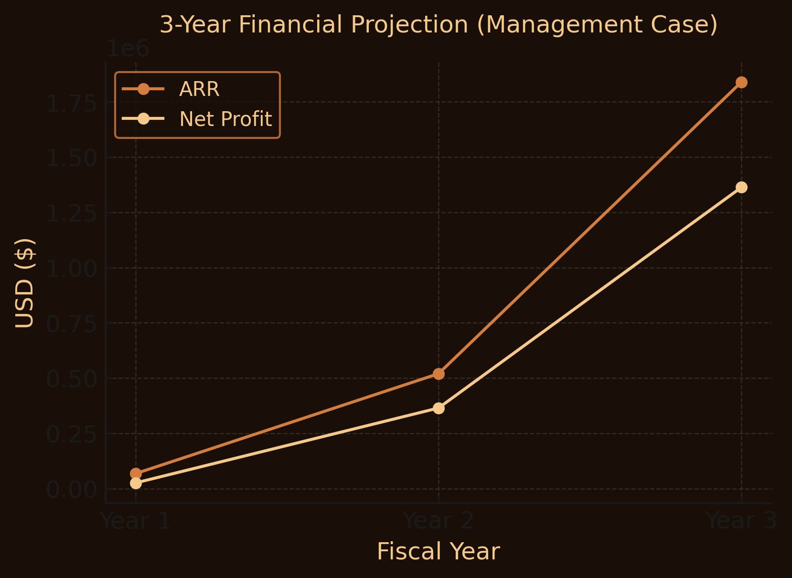

**📊 Chart 2 — *3-Year Financial Projection (Management Case)***

| **Metric** | **Y1** | **Y2** | **Y3** |
| --- | --- | --- | --- |
| ARR (USD) | 68 000 | 520 000 | 1 840 000 |
| Net Profit (USD) | 25 900 | 364 800 | 1 363 300 |
| Paying Customers | 57 | 291 | 948 |

**Type:** Dual line chart (ARR bronze #D37E3E / EBITDA cream #F4C98A).  
**X-axis:** Years 1–3; **Y-axis:** USD $.

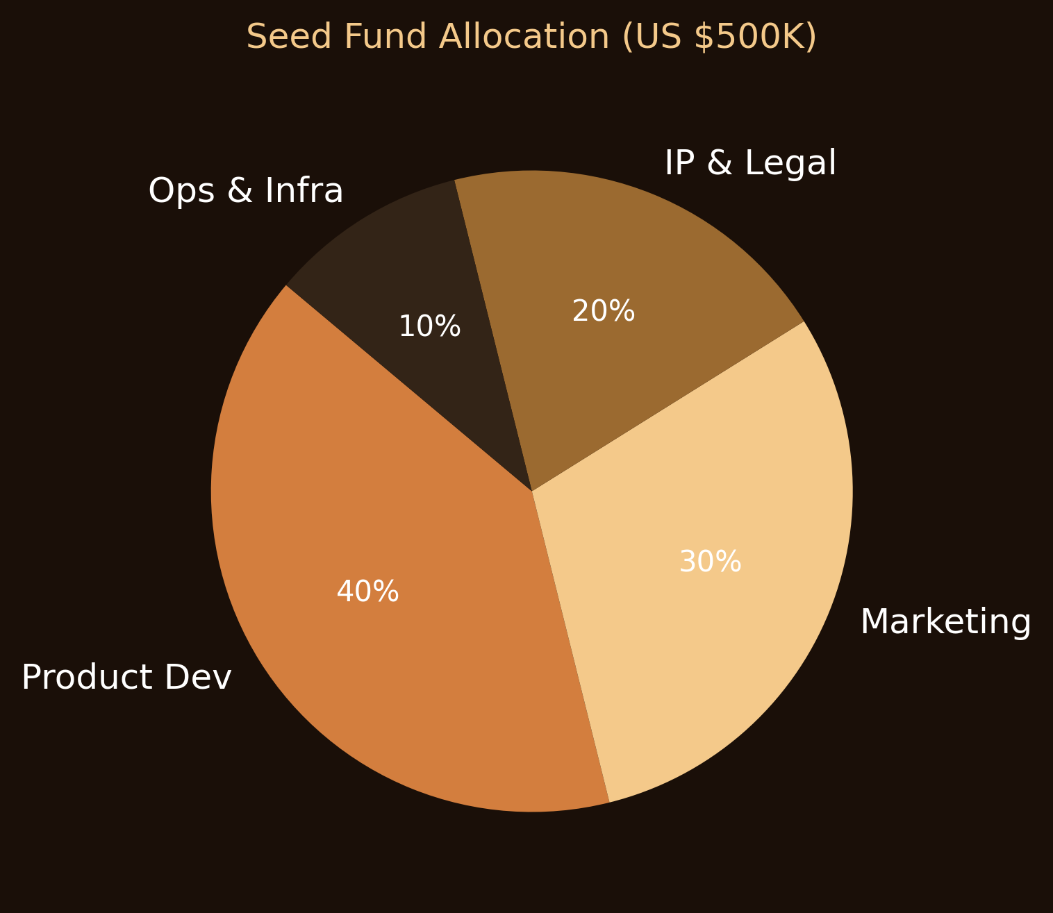**Five️⃣ Capital Use & Five - Ownership Impact**

**Use of Funds Pie Chart**

* Product Dev 40%
* Marketing 30 %
* IP & Legal 20%
* Ops & Infra 10 %

Seed raises $500 K → post-money $4.5 M → ≈ 11 % equity to investor.

**Six - Risk & Mitigation Highlights**

| **Risk** | **Mitigation** |
| --- | --- |
| Market adoption lag | Focus on dev-ops communities and self-host users |
| Competitive incumbents | Defensible IP + SPC/Cognitive Load differentiation |
| IP uncertainty | Patent filing in progress + trade-secret strategy |
| Capital burn | Low overhead / modular release schedule |

**Seven - Intellectual Property & Entity Plan**

* Company creation **BLB3D Labs LLC (Indiana)**; assign all software IP.
* File utility patent covering *Cognitive Load Latency Detection Method*.
* Copyright backend (FastAPI), frontend (React/Plotly), monitor scripts.
* Maintain trade secret for anomaly-scoring algorithm.

**Eight - Exit Potential & Valuation Benchmarks**

Comparable AI observability companies trade at **5× – 10× ARR** depending on growth and retention.  
If LLMscope reaches $5 M ARR within 5 years, EV range could be **$25 – 50 M**; $15 M ARR → **$75 – 150 M** (assuming AI premium).

Likely exits: Strategic acquisition (Datadog, New Relic, GitLab, or private equity)  
Series A/B growth rounds within 3–5 years.

**Nine - Appendix / Citations**

1. Grand View Research, *Artificial Intelligence Market Report 2025* – $279.2 B → $3.5 T, 31.5 % CAGR.
2. Growth Market Reports, *AI SaaS Market 2025–2034* – $115 B → $2 973 B, 38.4 % CAGR.
3. Growth Market Reports, *AI Model Monitoring Market 2025–2033* – $1.95 B → $24.5 B, 33.1 % CAGR.
4. Market.us, *AI in Observability Market 2023–2033* – $1.4 B → $10.7 B, 22.5 % CAGR.
5. Langfuse, Opik, Datadog pricing pages (accessed Oct 2025).